Scope for Pipeline Module for ADM One
Submitted by PiVisions Direct LLP
Date: 26th December 2022

Pipeline module will enable you to automate routine tasks for your clients based on predefined templates. Consider each pipeline as set of predefined tasks usually based on your services.
Important Features:

Creating Pipeline
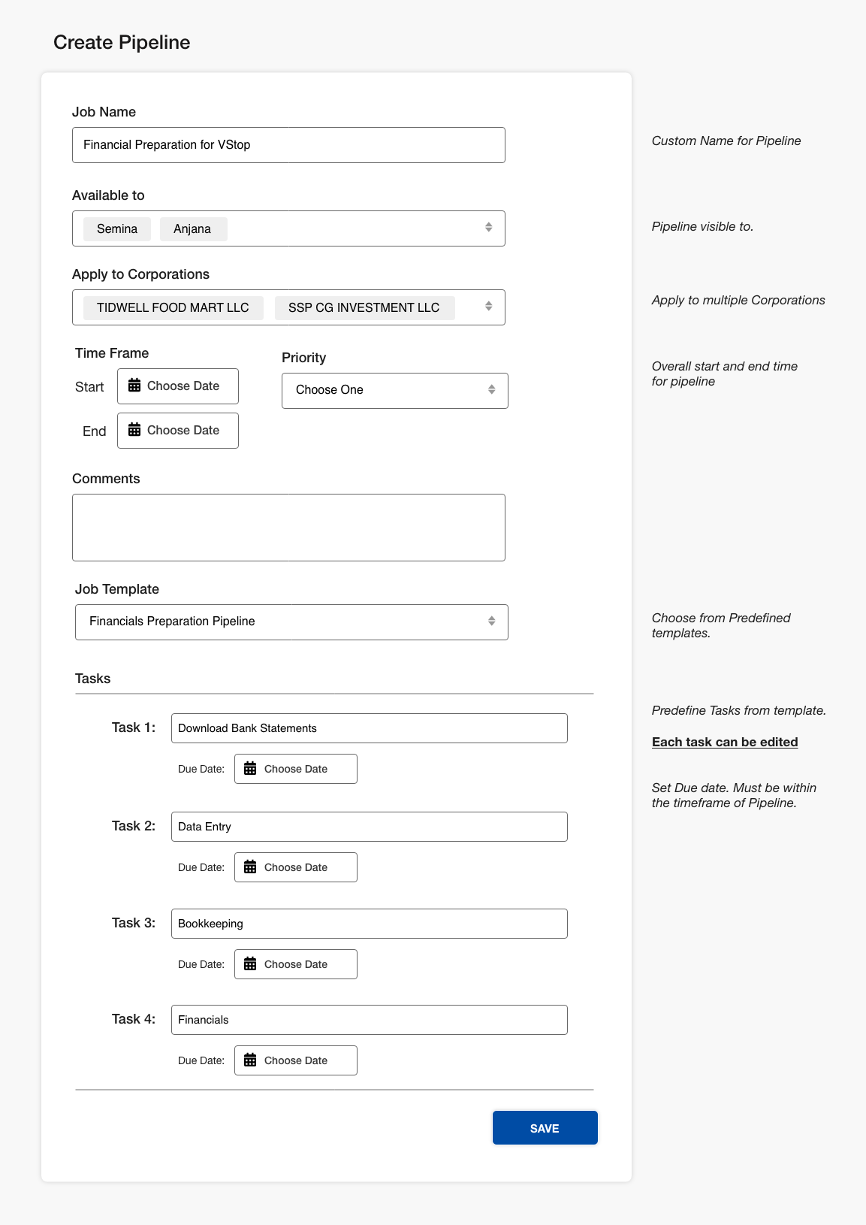

Tasks View

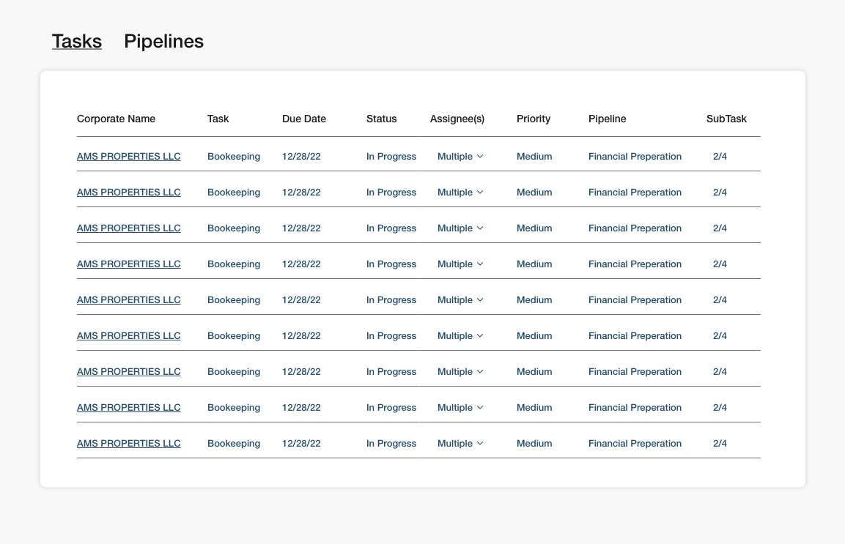

Pipeline View

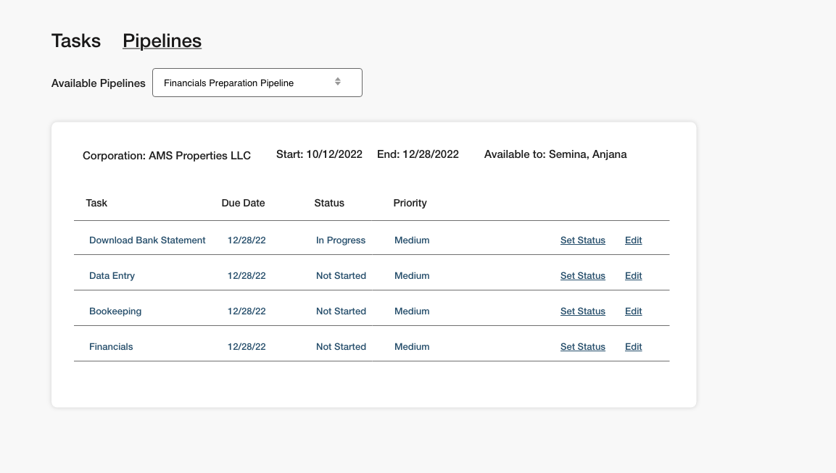

Job Templates:
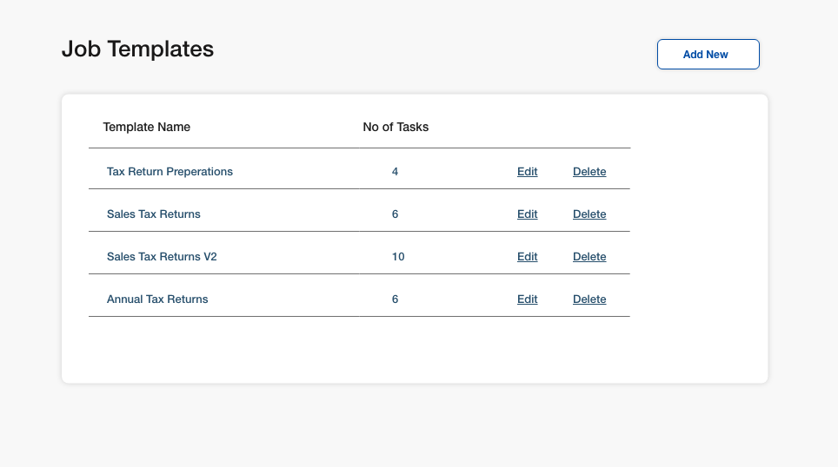

Add New Job Templates
